21. Develop a C program to implement worst fit algorithm of memory management.
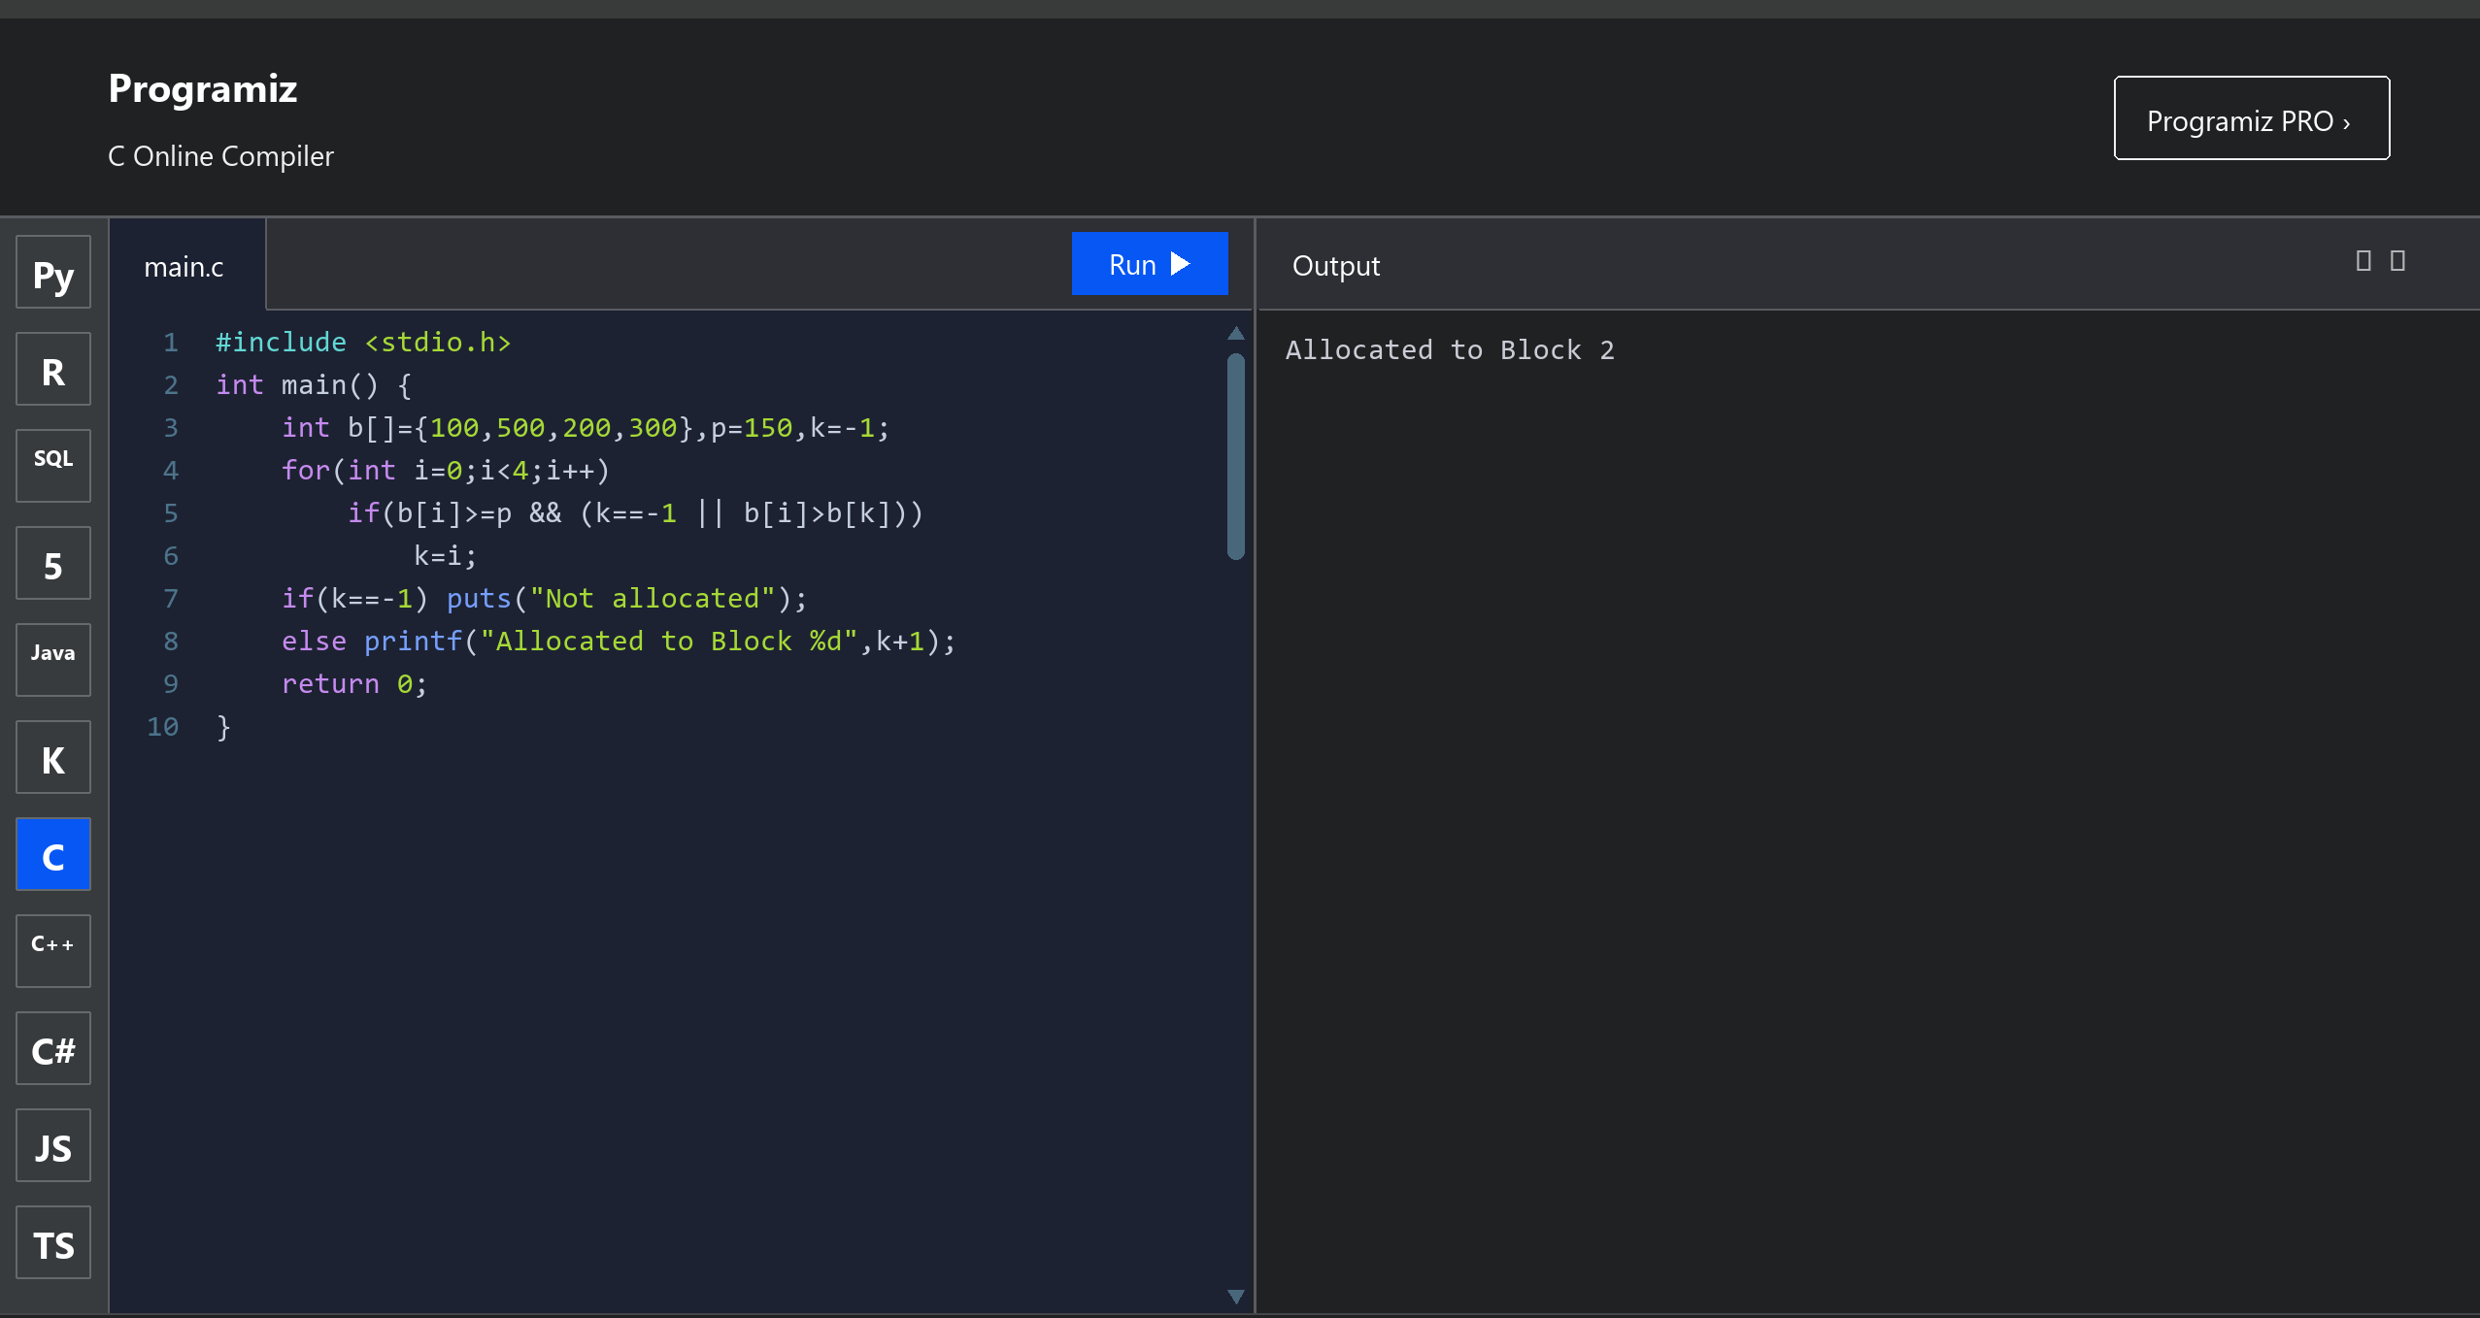

22. Construct a C program to implement best fit algorithm of memory management.
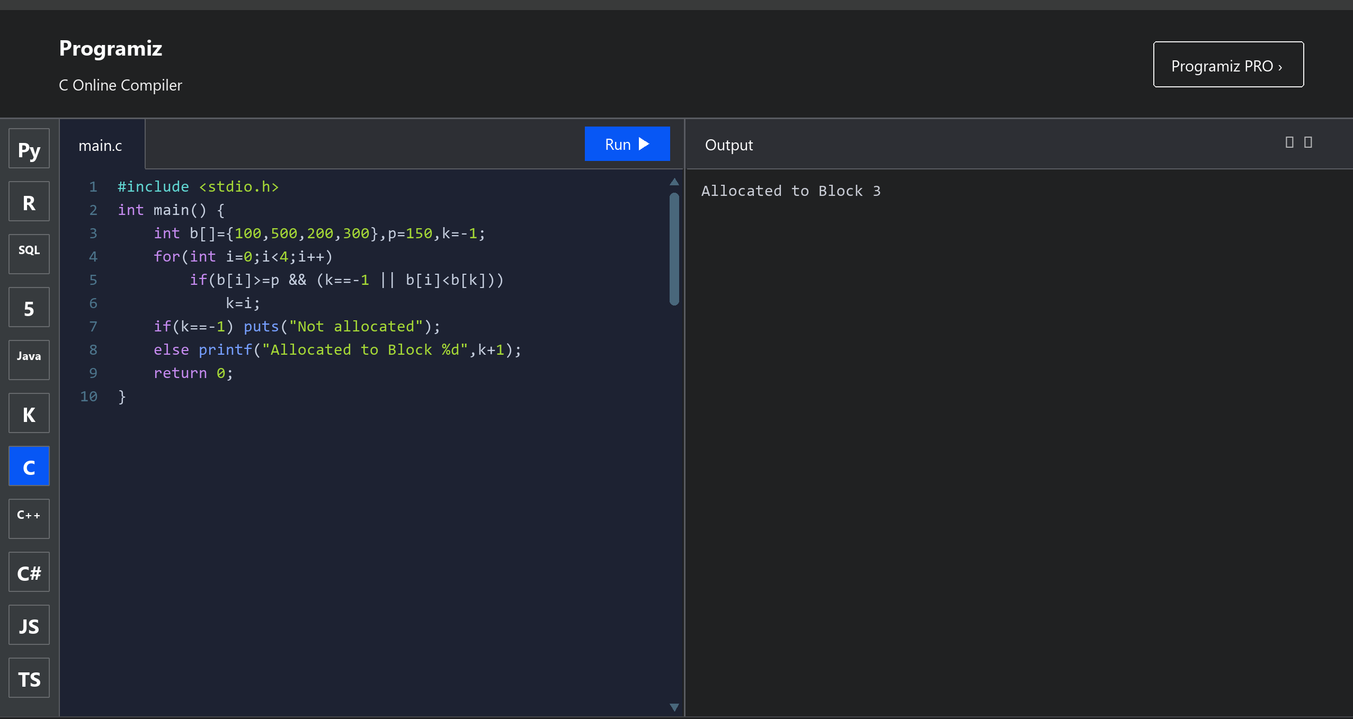

23. Construct a C program to implement first fit algorithm of memory management.
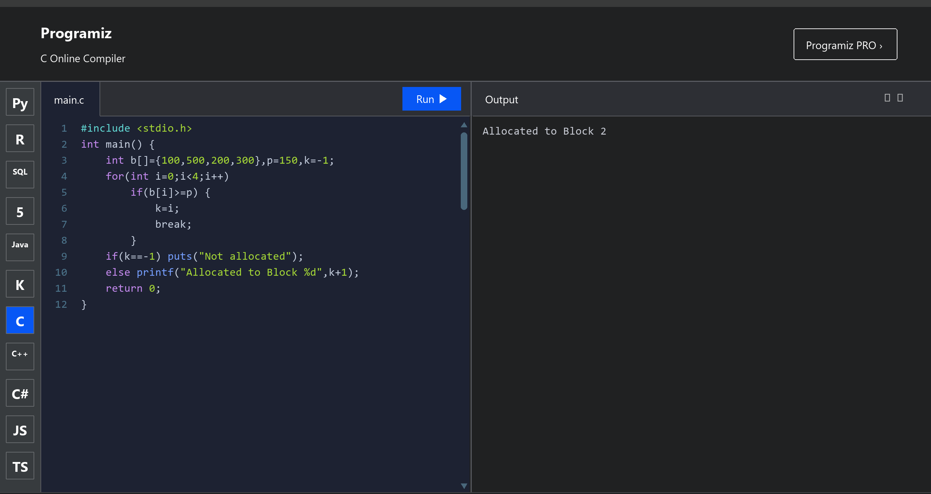

24. Design a C program to demonstrate UNIX system calls for file management.
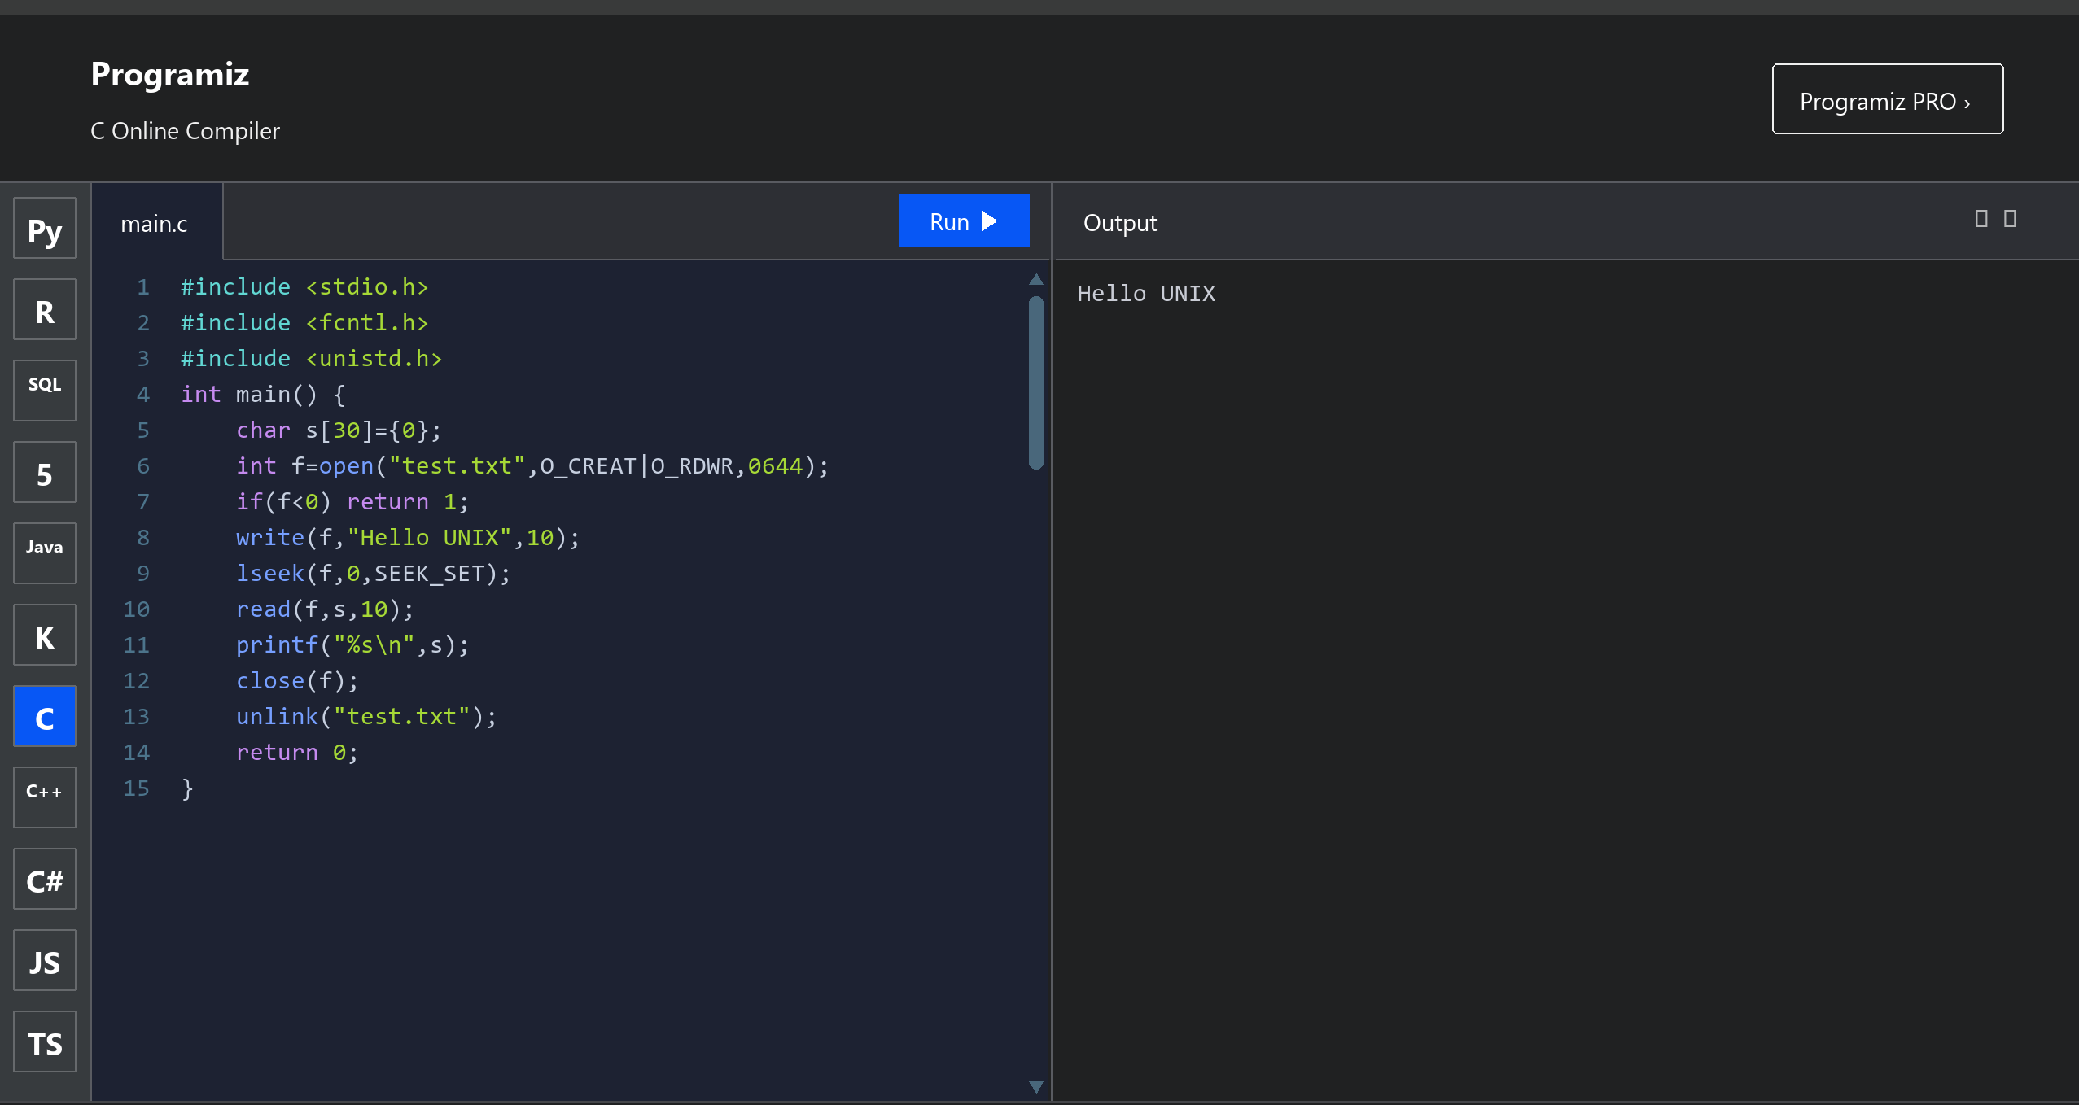

25. Construct a C program to implement the I/O system calls of UNIX (fcntl, seek, stat, opendir, readdir).
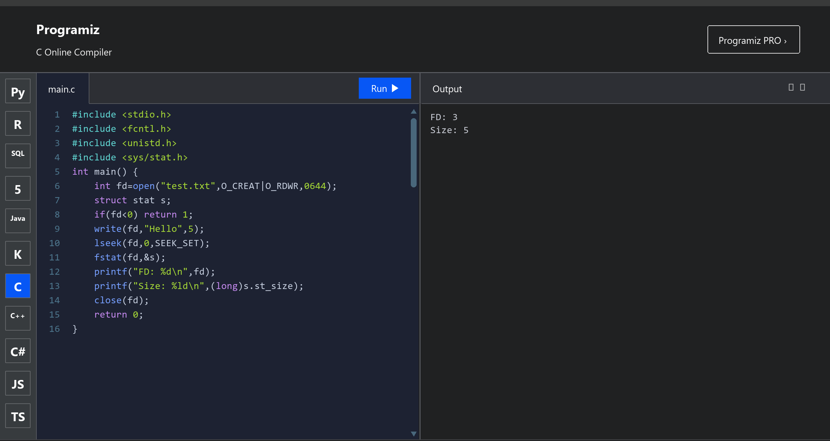

26. Construct a C program to implement the file management operations.
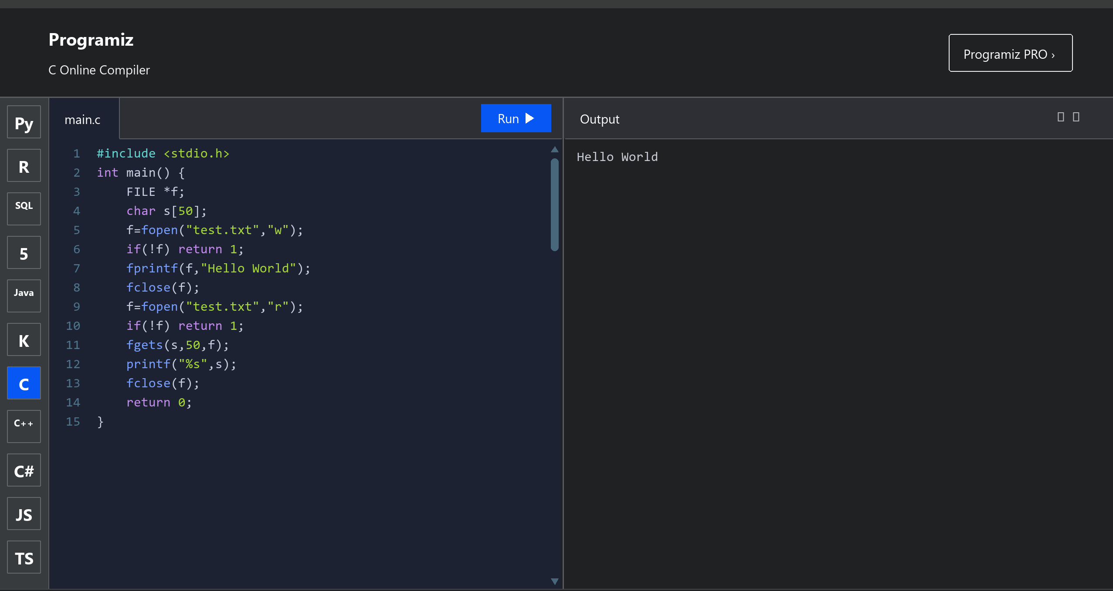

27. Develop a C program for simulating the function of ls UNIX command.
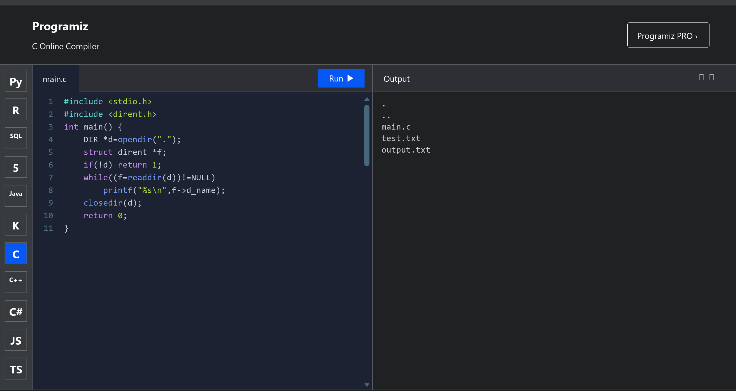

28. Write a C program for simulation of GREP UNIX command.
